Masai AI Developer Environment Setup Challenge
Name: amit prajapati
Date: 07 February 2026

Step 1: VS Code Welcome Screen
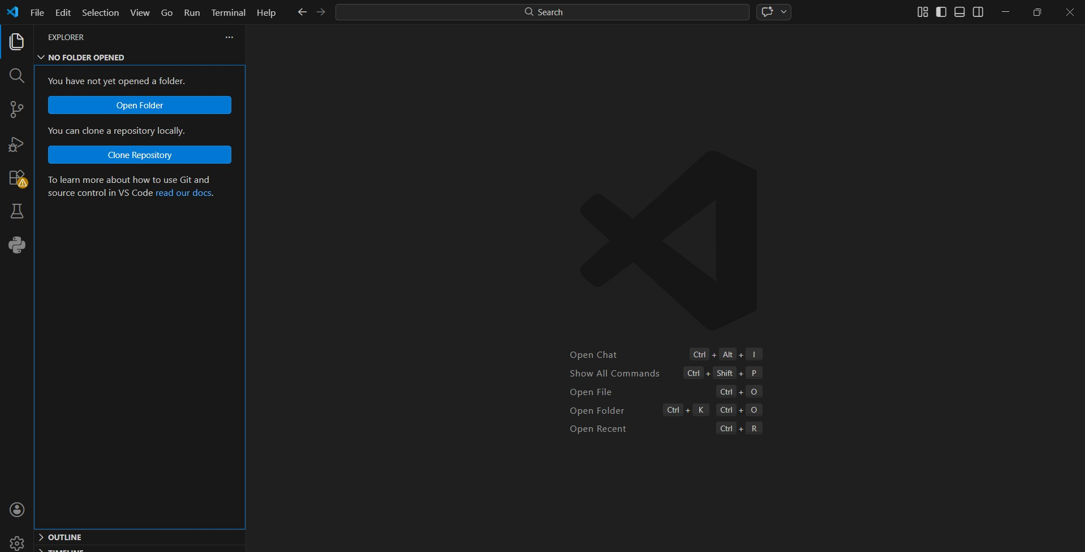

Step 2: Python Extension Installed
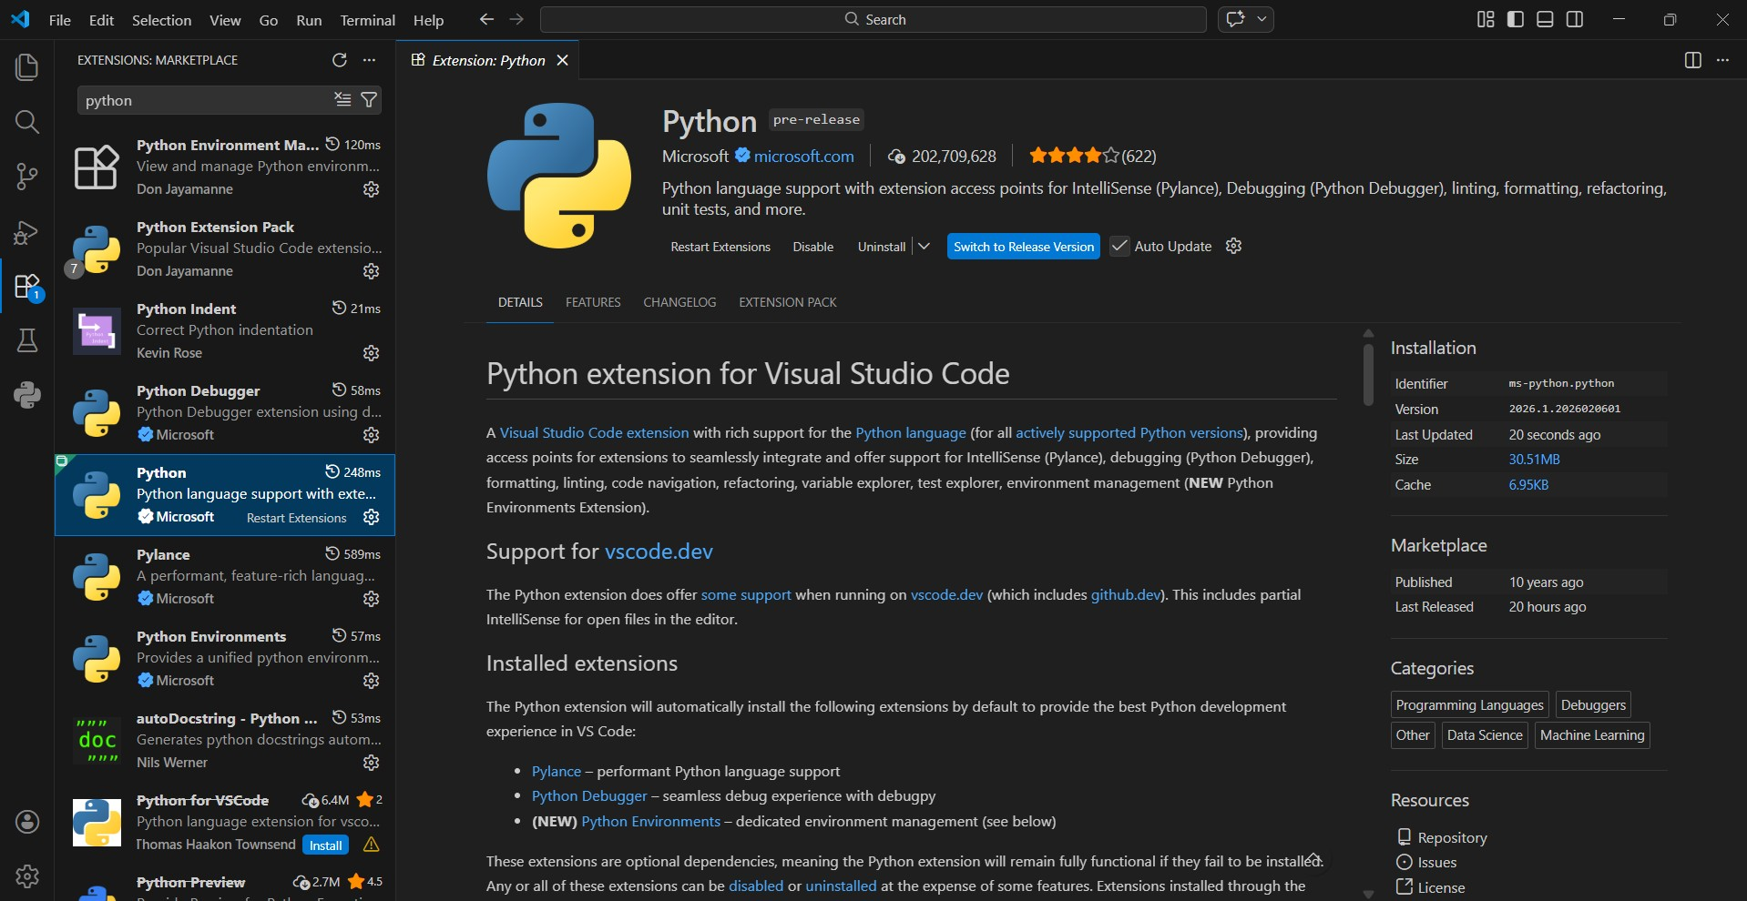

Step 3: Folder Structure in File Explorer
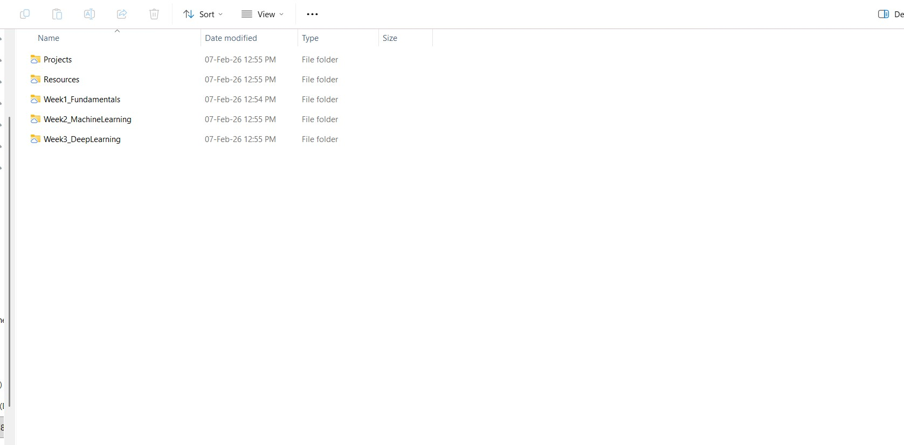

Step 4: AI_Projects Folder in VS Code Explorer
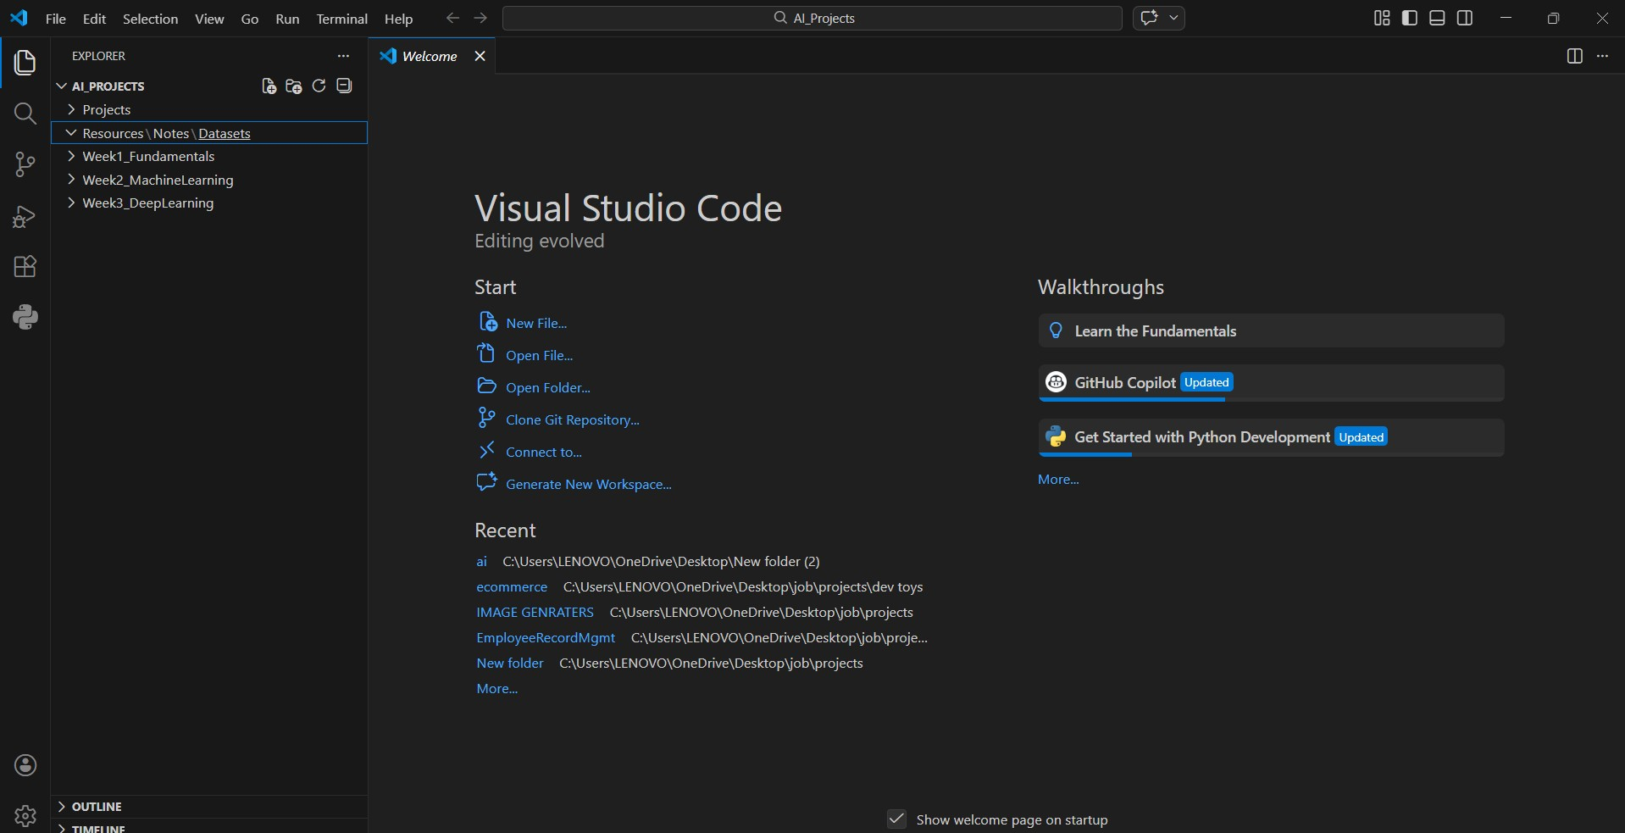

Reflection
An organized folder structure is crucial for AI projects because it keeps datasets, scripts, and models well‑managed, reducing confusion and improving collaboration. With a clear hierarchy, debugging and scaling projects becomes easier. I will use this setup throughout my learning journey to maintain clean code, separate experiments, and ensure my projects are production‑ready.

